Annual General Meeting of the Friends and Volunteers of Sheffield Music Hub
Thursday 10 May at 6:30pm
At Sheffield Music Hub – Red Tape

Attendees: Julie Justice, Gillian Hume, Ian Naylor, Audrey Foster, Sue Tinson, Sarah Deakin, Eleanor Farnsworth, Rosie Lockwood, Phoebe Powell

Apologies: Anna Turner, Brian Ellis, David Willington, Sarah Briggs.

MINUTES
Item
Welcome and Introductions by Julie Justice (Chair)
Chair’s Annual Report for the year.

Welcome everyone and thank you for attending this year’s AGM. We are so pleased to see everybody.

This is my fourth report as Chair of the Friends and Volunteers of the Sheffield Music Hub.

Introduction
Another year has quickly passed and has been busy as always, supporting the Hub staff who are working hard for young people to ensure music is in their lives. The new way of life that has emerged after COVID has changed the way we work. For example: meetings can be in person or online, or both at the same meeting. The lack of loose change? Using ‘Sumup’ machines to ensure we can still have a collection at the end of concerts.

We have regularly met this year to discuss ideas and what fundraising we can do.

We remain committed to the core purpose of the group, which aims to support Sheffield Music Hub both practically and financially, in their endeavours to offer more of Sheffield’s children and young people the very best musical education possible.

Going forward, I think, like last and the year before, we will need to strengthen the Committee, to share the workload and to move forward with new ideas.

What has happened this year?
Listed below are the activities that we have supported this year:
- Supporting concerts by scanning tickets, collecting donations, supplying, and serving refreshments
Live events are back fully!
With bucket shaking in the summer 22 term at the Proms night, open rehearsals, Big band at Red Tape and the Victoria Hall concert and in the Autumn 22 term at Octagon Centre and Cathedral for the Christmas Concerts and end of term performances.
- Grant applications:
No applications were made.
- Hoodies
This was led by Audrey, who sourced a local company that can produce hoodies with logos on them. A QRcode which was linked to an order form was created. Once submitted and we had received payment, a hoodie was added to the main order. Having purchased extra hoodies, these have been sold at events. All profits have gone to the Furthering Talent programme.
- Night of Mediumship
Audrey and Karen organised this new fund-raising ticketed event. With a raffle and ‘Spot the ball’ they raised a fantastic amount for the Free Music Places campaign.
How the money we have raised has been used
- Musical Stars Programme
Our main funding raising campaign this year was the Musical Stars / Furthering Talent Programme. The Musical Stars Fund aims to overcome barriers that prevent children and young people from spreading their musical wings. The funds raised from the scheme will ensure that: children are offered a 30 minute, weekly, specialist one to one lesson; free instrument hire (if needed); an appropriate ensemble place; dedicated time outside of the lessons for a tutor to offer guidance and support children pastorally with their musical journey.
- Music Group Bursaries
The hub offers a free or subsidised bursary scheme. Bursaries of 50% off a 20-minute shared lesson are available and FREE music group membership. This year we have paid for young people who are in receipt of free school meals and those who require a ‘financial needs’ discount (student pay a flat fee)
- Music Purchases
We have purchased music for the flute ensemble.
- Free Musical Places Campaign
A great opportunity for eligible children to join a Music Group for free. There are 25 groups including groups with no previous musical experience required.

Thank You
I would like to thank Audrey, our Treasurer. This is her first full year going solo (She had the support of the previous treasurer last year). Audrey has moved the charity forward by purchasing ’Sumup’ machines, which are essential now we are virtually a cashless world, ensuring we have been able to collect ‘virtual loose change via a card reader and also being able to sell hoodies at events. She has also looked into whether we need a gambling licence and, with the help of Sarah Deakin, looked at a new bank account. (Our current bank has started to charge us)

I would also like to thank Sue as Secretary. She has taken over from Kate, who left at the last AGM. She has hit the ground running by: organising meetings and taking the minutes; collating replies to volunteer requests for events to ensure we have enough people and they have the things they need ie Eventbrite logins, creating newsletters in Canva, and managing Whatsapp groups to keep everyone informed. To name but a few.

I would like to thank the other trustees Sarah Briggs for all her expertise on grant bid writing and Karen for helping at events and organising with Audrey the successful Mediumship night. Unfortunately, both Sarah and Karen are stepping down as trustees this time. We wish them well in their new ventures and a big thank you for all their support.

A big thank you to the rest of the committee, Anna, Rosie, Sophie and Sarah Deakin for coming up with ideas and with the volunteers (David, Zeena, Heather, Kirsty and Nick to name a few) helping with events. Whether you attend meetings or help at events, without you we wouldn’t be able to raise the amount of money we do. You are all amazing.

A big thank you to Gillian, our Music Hub’s representative; her unwavering support and knowledge has been fantastic.

Thank you, Ian and all his staff, for supporting us this year. We always know they are there to help when needed.

And finally, a big thank you to the parents, carers, their families and supporters for attending events so we have an opportunity to look after all your loose virtual or real change.

Thank you.

Julie Justice
Chair (Friends and Volunteers of the Sheffield Music Hub)

Treasurer’s report.

This is my first year as Treasurer for the Friends and Volunteers. The role has been enjoyable but also challenging. Julie (Chair) and I have gone through the accounts for me to get familiar with the processes involved.

This financial year was a more positive year post Covid, with the re-introduction of live performances. It has been wonderful to see the young people perform and to enable us to generate income for the Music Hub.

By purchasing (donated by myself) and using 2 Sum-up machines to capture electronic donations (due to people carrying less money) and payment of hoodies, they have been the most beneficial asset to us this year. We have still received donations via bucket shaking at concerts and through the Just Giving campaigns.

From the handouts of the balance sheets, we can see it is broken down into several categories to help show where the money is allocated to.
- The first column is Sundries / Bank transactions – this includes one-off payments and money moving from one of our bank accounts to another.
- The next four columns relate to our current Just Giving campaigns.
- The next column is income from Just Giving that wasn’t linked to a campaign.
- The last two columns are campaigns that are closed but still has transactions going through this year.
With information presented in this format, it has afforded us with a clearer picture on the campaigns and actual monies raised and spent, which we can relay back to the Music Hub for them to use and plan / budget for the following year.
In respect of the Just Giving pages, Julie and I have spent considerable time studying the reports in Just Giving, to identify what has been allocated to each different campaign and getting a true reflection on income raised- this includes Gift Aid. It is also to be noted that using Just Giving also incurs a charge of £18 per month. This charge and gift aid is not reflected in the totals that appear on the Just Giving campaign page, but it is important to note the importance of capturing that data and having it reflected clearly on a balance sheet.
As you can see from the balance sheet, the opening balance at the beginning of that financial year was £15,711.79 and income made from fundraising was £11,887.56.
Income
Our sources of income have been:
- Concert takings and Collections |  | - Grant and Donations
- Just Giving from all campaigns |  | - Hoodies
- Fundraising |  | - Bank Interest
Whilst we have made a profit through the sale of hoodies, it is difficult for us to pinpoint how much profit. As not all income from hoodies was received in cash, some of the money went straight into the Furthering Talent campaign page in Just Giving and the Sum Up machines. Whilst this was helpful, they are limited in the information they hold and we cannot identify if the money was for the purchase of a hoodie or a general donation.
In addition, we have some hoodies still in stock and they will be sold in the next financial year.
Expenditure
With regards to expenditure, monies have funded:
- Bank charges
- Just Giving Charges
- Bursaries – request from the Hub
- Hoodie purchases
- Music sessions for HubFest
- Samba equipment purchases.
It can be noted that, as requested by The Music Hub, we have concentrated on fundraising for the Furthering Talent Programme, which is where the majority of Just Giving, fundraising events and bucket shaking money is targeted.
Our total expense for the financial year was £9.082.38 with a final closing balance of £18,516.97
Finally, I look forward to our new financial year and continuing the support we offer for the young people of Sheffield and the partnership working with Sheffield Music Hub.
Thank you.

Audrey Foster
Treasurer (Friends and Volunteers of the Sheffield Music Hub)

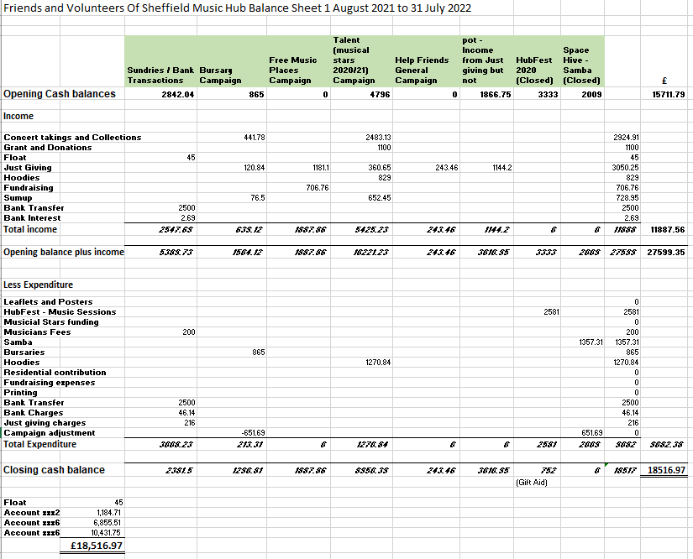

Vote of office holders and Trustee members

Office holders:
Chair Julie Justice
- Proposed by Audrey Foster
- Seconded by Sue Tinson

Secretary Sue Tinson
- Proposed by Julie Justice
- Seconded by Audrey Foster

Treasurer Audrey Foster
- Proposed by Sue Tinson
- Seconded by Julie Justice

Trustees
- Rosie Lockwood
- Proposed by Julie Justice
- Seconded by Gillian Hume
- Anna Turner
- Proposed by Julie Justice
- Seconded by Gillian Hume

Ian Naylor, Head of Music Education addressed the meeting.
Key points were:
Reflecting on HubFest (campaign that has now closed). recent concerts have demonstrated the Hub’s value in terms of diversity and inclusion, but still more work to done on this. The remaining Gift Aid amount on this campaign will be used to commission work in this area.

Ian emphasized the importance of the Friends and Volunteers work, and how they had supported the Hub staff. The donations and amounts raised had positively impacted at management level within the Hub, enabling staff roles to continue, and therefore for the Hub to continue to offer more of Sheffield’s children and young people the very best musical education possible.

Upon request he also gave an update regarding the Harmony Works and status of the funding, which is looking very positive.

7:30pm meeting closed

