Sheffield Music Hub and Partners what we are up to and how to get involved!

Sheffield Music Hub will be re-releasing a Song of the Week, and a Challenge of the Week every Wednesday at 4pm throughout the Summer Holidays. We have ensured there is a mix of KS1, KS2 and KS3 videos so every age can get involved. Make sure you don’t miss out by subscribing to our YouTube Channel Here!
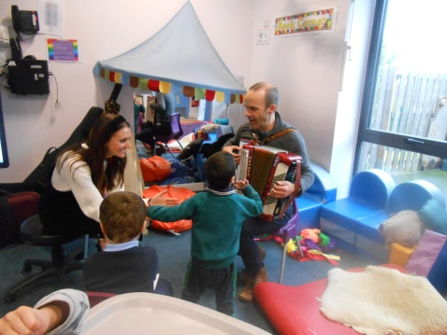
The OUR STREET OUR SONG project has been running for the last 2 years, with musicians POLLY IVES, MARTIN HARWOOD, LUKE CARVER GOSS and MOONY WAINWRIGHT working with staff and over 2000 children and their families in 18 nurseries, children’s centres and schools across South East Sheffield.
The musicians have been focussing on fun and creative music making and creating original music and songs with children and families, using inspiration from their own surroundings and heritage. When Covid 19 happened, we had to cancel the final few face to face sessions and the planned final big celebration event at City Hall, and we had to work out how to re-invent delivery of the final part of the project.
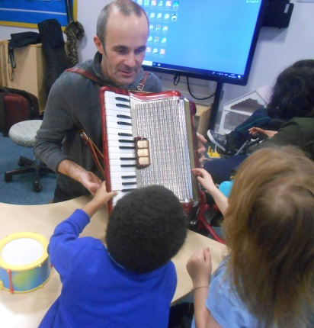
So, as well as the musicians keeping in contact with the staff on an individual basis, we decided to create the OUR STREET OUR SONG PUBLIC YOUTUBE CHANNEL which was launched in May.
We are really excited because it showcases all the amazing music making together which the project has produced.

The musicians are currently working on creating virtual live performances of 3 of the songs which would have formed part of the Final Celebration Concert at City Hall – these will be uploaded soon.

The videos aim to support the EYFS framework, particularly phonics, counting, creativity, and are also suitable for KS1 so we hope that staff in nurseries and schools and parents will continue to find it a useful resource for years to come.

There are 4 different playlists to help everyone find their way around the site.
- Favourite Songs from this project, performed by the musicians
- New music performed by the musicians. - songs or new lyrics that have been created with the brilliant children and adults involved in the project.
- New music created and performed by the children and their grown-ups in the project.
- Cool stuff from other projects - This includes videos the musicians have filmed outside of this project which we think you will find enjoyable and interesting.
We are grateful to YOUTH MUSIC and SSELP (Sheffield South East Learning Partnership) for funding this project.

Create Sheffield is Sheffield’s Local Cultural Education Partnership. We aim to engage all children and young people across Sheffield with the arts, heritage and cultural industries, working to remove barriers to engagement where they exist.
In light of the unprecedented challenges Create Sheffield has also adapted, and we continue to nourish and support the joined-up effort that is needed to provide children and young people with creative and fun learning opportunities in these challenging times. We know we can play a key role in ensuring the quality and vibrancy of Sheffield is available to all who want to get involved, and particularly in removing barriers to the most vulnerable.
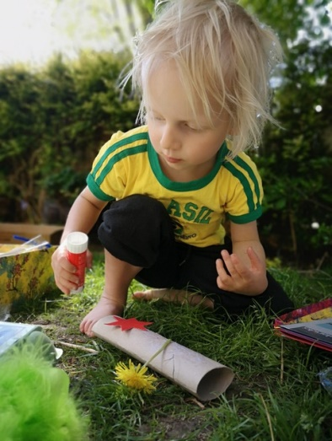
Sheffield #homeadventures
Just when we were about to release our Sheffield Adventures, like everyone else, we were hit by lockdown. Knowing that Sheffield families needed support now more than ever, we re-wrote and released #homeadventures, offering creative ideas useful for your home environment and social distancing. Visit our #homeadventures page.
We have also been collecting a wide range of links to creative resources and fun activities that support children and young people in Sheffield during this period of home-learning and have saved them all on our Lockdown Resources page. Our list is just the beginning. We want to grow these ideas for all ages & abilities and include all types of art form and cultural activity. If you have activities you would like to add to our #homeadventures collection, our Lockdown Resources or something else you want to tell us about. Send us your ideas.

Sheffield Learning Together
We have been working alongside Learn Sheffield, our Partners and friends across the city in contributing fun and creative learning activities which children, young people and families can take part in at home, the majority without the need of additional resources or internet access. Sheffield Learning Together is a 16-page supplement, written by teachers and organisations in Sheffield and has been printed in the Star Newspaper each Thursday.
Create Sheffield have also contributed some of their Sheffield Adventures, in addition to supporting their arts and cultural Partners to get involved in the VAS Sheffield Healthy Holidays Activity Guide. The aim of the guide is to boost the health and wellbeing of children and young people during the summer holidays. The publication will go out every Monday in The Sheffield Star and Healthy Hampers that will be delivered to families across the city.
Keep an eye out on our website, Twitter, Instagram, Facebook & sign up to our newsletter for more information!

Music in the Round has had a busy lockdown creating many videos for you to enjoy at home. Their May Festival saw some interactive videos you can still watch now! These videos are suitable for KS1 and KS2 children. To find more videos subscribe to Music in the Round’s YouTube Channel
Click here to see Sir Scallywag and the Battle of Stinky Bottom, an amazing performance your children can get involved with at home.

Click here to see Polly Ives in her Concerteenies at home session where using a professional cellist and violinist she asks you to draw a response to a song – get your colours out and have a go!

Click here to watch the ‘Meet the Musicians’ series of videos which is an amazing way to get your children learning instrument names, and what they can do!

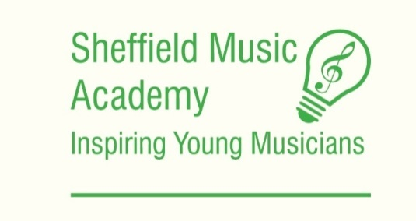
Since lockdown was announced and schools were suspended back in March 2020, we at the Sheffield Music Academy have been extremely fortunate to have a wonderfully resourceful and creative collection of individuals who have been able to offer and engage in fantastic online tuition for our students.
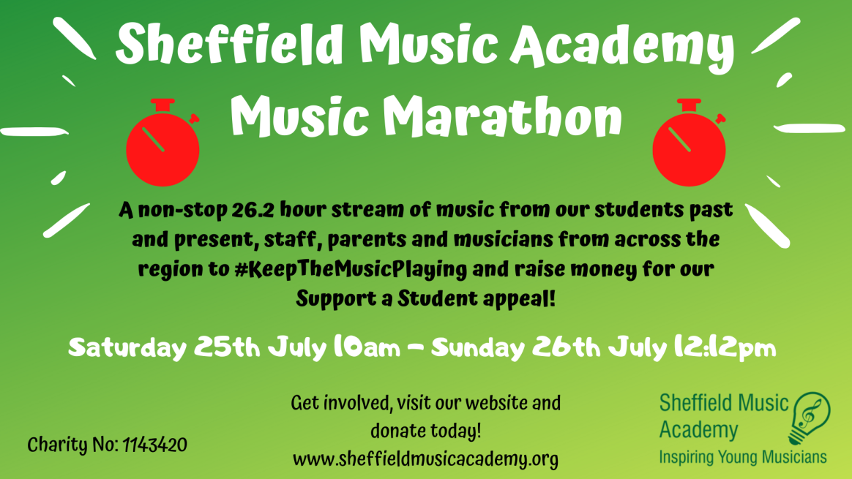

The Music Marathon we will be streaming both pre-recorded videos and live performances. We wanted to create an event that would bring together our students, staff, and parents to celebrate all the hard work our students have put into their learning. Our most ambitious project yet, we will be showcasing not only our students, but parents, staff and musicians from across the region to celebrate the art of music-making.
Midweek Concert Series
In the world we used to know, SMA ran weekly ‘Lunchtime Concerts’ on our Saturday teaching day. The concerts would be full of students performing pieces they have been working on with their teachers. We still wanted to showcase the fantastic work our students have put into their learning, even if it is not in person right now. Our new Midweek Concert Series is a collection of videos of our students performing pieces they have been working on with their teachers and pieces they really enjoy playing. We are releasing these videos weekly on a Wednesday, with the full collection uploaded onto our YouTube channel.
Through both the Midweek Concert Series (see below)and training for the marathon, SMA students have gained invaluable skills in recording, presenting themselves and adapting to new ways of performing. We are a very proud musical community and in times like these it can be easy to lose the sense of community, which is why we are thrilled to be offering this platform for performance to our hard-working cohort.
As a small music education charity, SMA hope that the Music Marathon will encourage new audiences and help raise vital funds lost during lockdown. We are proud to be raising money for our ‘Support a Student’ appeal, which can make the difference that will allow us to continue to inspire young musicians and help them grow as individuals.
Live Music Now is delighted to share our new online Video Library for children with you. This is a set of inclusive, participatory concerts recently recorded by some of the young professional musicians that work with Live Music Now. The videos are inspired by their work in SEN settings and are designed to be inclusive for children with additional learning needs.
Live Music Now has also moved some of its other work online. We are now delivering:
- online live sessions and musical residencies via Zoom, Microsoft Teams, Google Classroom or other school-managed platforms;
- new resources to help staff deliver musical activities
- online sessions with families at home via Zoom with support and guidelines

Sheffield Music School is a fun and friendly local music centre that teaches small groups of children and young adults in a broad range of genres. From classical to song-writing, theory to jazz listening, we run bespoke classes that best suit the individual students. During lockdown we have continued our classes with a diverse programme of music making and listening with an end of year concert for the children and one coming in August by the children.

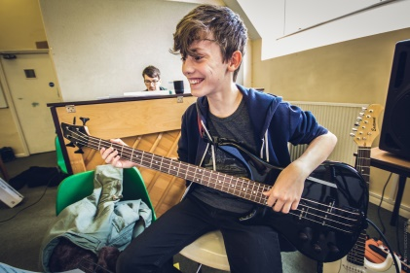
We have a number of bursaries and scholarships available to support students wishing to join us. Whether you need extra support in theory, would like a coach for your song writing or would simply like to join us for a whole morning of music making, let us know and we will try our best to see if we can find a programme that suits you and your child.

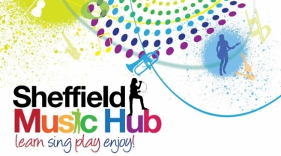
Sheffield Music Hub would like to thank all of our partners for involving us in their organisations, especially through this challenging time. As a city, Sheffield has a wealth of musical activity, and lockdown hasn’t stopped us. We hope you have a fabulous summer and fill it with music!
See you in September!

