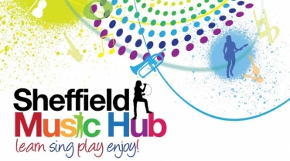
Music at Home!
Get involved and enjoy music at home or in school
During times of difficulty we often turn to music in its many varied forms to help us through. Whether it's music to listen to which cheers us up and lifts our mood, music that makes us cry, music that makes us want to dance and sing, or just as a distraction from everything around us; now more than ever music has the power to help you and your child to soldier on....so ....here are some suggested activities to help!

Each week you will receive:
- Song of the week - warmups and a new song to learn
- Challenge of the week - a simple game or idea for your children to have a go at
- Signposts - a guide to other resources you might enjoy!
So here we go with Week 9...
Suitable for KS2
After another exciting and engaging warm up from Charlotte, this weeks' song has a slightly different feel! 'Poor Poor Bird' sounds mournful...can you tell us what you think it means and what makes it sound different to other songs? It is important to consider the meaning of a song before we perform it, if we don't know what it means, neither will the audience! Tag us in your ideas @sheffmusichub on Facebook or Twitter.
Song of the Week!
Suitable for KS1
'Can you guess the word that I am singing?' asks Polly Ives as part of the Concerteenies Series. Using music to learn your phonics is an amazing way to engage your students. See if you can fit some other words in, what about a 'c-a-r' and 'b-e-d' or your 'h-a-t'? To see more videos from Polly subscribe to the Concerteenies Youtube Channel Here.
Challenge of the Week!
Signposts!
City of Sheffield Festival Band - For EVERYONE!
Here is our amazing Festival Band bringing joy and happiness to the world with their video 'You've Got A Friend In Me'. Have a watch and a listen, we hope it inspires more music making in your schools!

Sheffield Music Academy Music Marathon!
This weekend the Sheffield Music Academy takes on the ultimate music making challenge, 26.2 hours of music making, non-stop! To find out more and support such a wonderful organisation click here.

Katumba - Suitable for KS2
The moment is here to get involved in the drumming and dancing split screen video! To find out how click here and enjoy rocking away to the Katumba #LifeAfterLockdown song.

Music Mark - For School Colleagues
Bob Cuff, headteacher at Manor Lodge Primary School in Sheffield, understands the importance of Music as the foundation of a good education. He recently spoke passionately about the importance of Music at Music Marks Summer Summit. Here he expands upon the value of Music as an education building block. Thank you Mr Cuff for championing music in your school!

Our updates aim to give you some really simple tasks that children of all ages can take part in! Please join in and let us know how you are getting on by tagging us on Facebook or Twitter!

