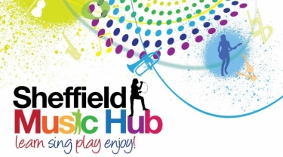
Music at Home!
Get involved and enjoy music at home or in school
During times of difficulty we often turn to music in its many varied forms to help us through. Whether it's music to listen to which cheers us up and lifts our mood, music that makes us cry, music that makes us want to dance and sing, or just as a distraction from everything around us; now more than ever music has the power to help you and your child to soldier on....so ....here are some suggested activities to help!

Each week you will receive:
- Song of the week - warmups and a new song to learn
- Challenge of the week - a simple game or idea for your children to have a go at
- Signposts - a guide to other resources you might enjoy!
So here we go with Week 6...
Song of the Week - Suitable for KS3 students
This weeks' song comes from our fabulous Music Leader Caroline Hallam. Here Caroline looks at a 3 part song, "Mango, Kiwis and Pineapples" you can sing by yourself, or with your whole family! Record yourself singing 1 or more of the parts and share it with us so we can see how you have got on!
Song of the Week!
Challenge of the Week!
Challenge of the Week - Suitable for KS2 children and above
Charlotte challenges you this week to use colours to guess the song she is thinking of. If you can guess the piece, tag us in your answer on Facebook or Twitter with #sheffmusichub. Click here to take part!
Signposts!
Signposts

Concerteenies - KS1 children
The ‘concerteenies’ YouTube channel gives some amazing activities designed for little ones who love music! Polly Ives has produced the short videos to get children singing and learning together. Here is an example of a counting song from 1-5 using the tune 'Jelly on a Plate'; subscribe to their YouTube channel for more exciting videos!

English Touring Opera (ETO) - Children, adults and SEND opportunities!
Singing lessons
ETO are producing two series of singing lessons: one for adults, and one for kids. THEY ARE FREE (!) and all delivered by artists who would have been singing on this spring tour. Click Kids lessons for children and Adult lessons for grown ups!
Online workshops for children with SEND
ETO are also delivering free online music workshops for children with SEND at 11am on Wednesdays via a YouTube Live stream. The past workshops are also available to watch. This is an amazing opportunity to get children involved in some really high quality music making with the experts! Links to the workshops are on their website.

Our updates aim to give you some really simple tasks that children of all ages can take part in! Please join in and let us know how you are getting on by tagging us on Facebook or Twitter!

