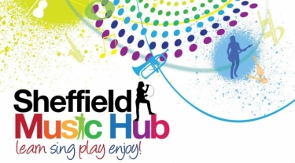
Music at Home!
Get involved and enjoy music at home or in school – Wednesday 6th May 2020
During times of difficulty we often turn to music in its many varied forms to help us through. Whether it's music to listen to which cheers us up and lifts our mood, music that makes us cry, music that makes us want to dance and sing, or just as a distraction from everything around us; now more than ever music has the power to help you and your child to soldier on....so ....here are some suggested activities to help!

Each week you will receive:
- Song of the week - warmups and a new song to learn
- Challenge of the week - a simple game or idea for your children to have a go at
- Signposts - a guide to other resources you might enjoy!
So here we go with Week 3...
Suitable for KS2 and above
Song of the Week!
This weeks' song comes from Caroline Hallam, Music Vocal Leader. Caroline uses exciting warm ups, gets your brain working with ‘Alive Alert Awake’ and finishes with the uplifting piece 'I'm Gunna Shine', view on YouTube here.

Suitable for any age!
Challenge of the Week!
Laura Steelyard is back with her challenge and this week it's Body Percussion! Create your own body percussion using a really simple step-by-step method. No experience needed, click here to view on YouTube.

Signposts this week are primarily for schools and teachers! *LET’S GET EVERYONE SINGING!
This week sees the launch of an exciting Big Sing Project from Norfolk Music Hub. This project gives schools the opportunity to get their children singing and dancing, with a final performance on Friday 19 June at 2pm. The resources are from our partners at Charanga which enables families to access the resources from any device whether they are at home or in school. For more information and to sign your school up click here.
Signposts!
Keep an eye on their social media channels for big announcements each week on which performers will be joining them - Friday at 2pm!
Follow Norfolk Music Hub on:
Facebook
Twitter
Instagram

*Sing For Pleasure
SfP KnowledgeHub weekly webinars are designed to give you a host of useful tips and suggestions on a wide range of choral topics to put into practice when Covid-19 lockdown measures ease. Each webinar will take place on a Wednesday at 7.00pm for 40 minutes. To sign up click here.

*Learn Sheffield Star Supplement - suitable for a range of ages from KS1 to KS3
Learn Sheffield have worked with Sheffield Star and partners across the city to produce a 16 page document each week (Sheffield Learning Together) which includes many activities for children to try at home! Of course they aren't all musical, but it is well worth signposting your parents to for some ideas at home.

Our updates aim to give you some really simple tasks that children of all ages can take part in! Please join in and let us know how you are getting on by tagging us on Facebook or Twitter!

