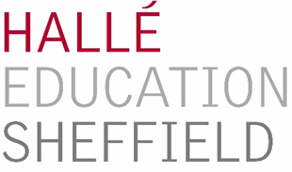

HALLÉ FOR YOUTH 2020
CONCERTS FOR SCHOOLS

MUSIC, MIND & MOOD
THE CITY HALL, SHEFFIELD
Friday 6th March 2020 at 10:45 and 13:00

CONDUCTED BY tbc
PRESENTED BY TOM REDMOND
ANNA CLYNE Masquerade (with visuals) 5’
TIM JACKSON Passacaglia 4’
WAGNER Lohengrin: Prelude to Act III. 4’
ARVO PÄRT Cantus in Memoriam Benjamin Britten (cut version) 4’
†SHOSTAKOVICH Symphony No.10 in E minor, II - Scherzo 4’
LIN MARSH/arr. Pickett Believe 3’
MICHAEL GIACCHINO Star Trek: Into Darkness 3’
†BIZET Carmen: Prelude and Habanera (feat. soprano soloist from the RNCM) 5’
SIBELIUS Valse Triste 4’
TCHAIKOVSKY Swan Lake: Finale 6’
† BBC Ten Pieces

Music duration – 42’
Concert duration – 65’

